Quiz 06

**Question 1.**

Consider the following axioms: a. All hounds howl at night.

1. Anyone who has any cats will not have any mice.
2. Light sleepers do not have anything which howls at night.
3. John has either a cat or a hound.
4. (Conclusion) If John is a light sleeper, then John does not have any mice.

Use Resolution to prove (or disprove) the Conclusion

|  |  |  |
| --- | --- | --- |
| No. | Sentences | Explanation |
| 1 | ∀hound: howl(hound) | From KB |
| 2 | [∀x, ∃cat: own(x, cat)] → [∀mouse: ~own(x, mouse)] | From KB |
| 3 | [∀x, ∀y: lightSleeper(x) ^ howl(y)] → [~own(x,y)] | From KB |
| 4 | [∃cat: own(John, cat)] v [∃hound: own(John, hound)] | From KB |
| 5 | ~[lightSleeper(John)→ [∀mouse: ~own(John, mouse)]] | Negate conclusion |
|  |  |  |
| 6 | [~own(x, P(cat))] v [~own(x, mouse)] | 2 |
| 7 | [~lightSleeper(Q(x))] v [~howl(y)] v [~own(Q(x),y)] | 3 |
| 8 | [own(John, P(cat))] v [own(John, R(hound))] | 4 |
| 9 | lightSleeper(John) | 5 |
| 10 | own(John, mouse) | 5 |
| 11 | ~howl(y) v ~own(John,y) | 7, 9  {Q(x)/John} |
| 12 | ~own(John, P(cat)) | 6, 10  {x/John} |
| 13 | own(John, R(hound)) | 8, 12 |
| 14 | ~own(John, hound) | 1, 11  {y/hound} |
| 15 |  | 13, 14 |

So, the KB can derive the conclusion: If John is a light sleeper, then John does not have any mice.

**Question 2.**

Consider the following axioms:

a. Every child loves Santa.

1. Everyone who loves Santa loves any reindeer.
2. Rudolph is a reindeer, and Rudolph has a red nose.
3. Anything which has a red nose is weird or is a clown.
4. No reindeer is a clown.
5. Scrooge does not love anything which is weird.
6. (Conclusion) Scrooge is not a child.

Use Resolution to prove (or disprove) the Conclusion

|  |  |  |
| --- | --- | --- |
| No. | Sentences | Explanation |
| 1 | ∀x: child(x) → love(x, Santa) | From KB |
| 2 | ∀x, ∀y: reindeer(y) ^ love(x, Santa) → love(x,y) | From KB |
| 3 | reindeer(Rudolph) | From KB |
| 4 | redNose(Rudolph) | From KB |
| 5 | redNose(x) → [weird(x) v clown(x)] | From KB |
| 6 | ∀x: reindeer(x) → ~clown(x) | From KB |
| 7 | ∀x: weird(x) → ~love(Scrooge, x) | From KB |
| 8 | child(Scrooge) | Negate conclusion |
|  |  |  |
| 9 | ~child(x) v love(x, Santa) | 1 |
| 10 | ~reindeer(y) v ~love(x, Santa) v love(x,y) | 2 |
| 11 | ~redNose(x) v weird(x) v clown(x) | 5 |
| 12 | ~reindeer(x) v ~clown(x) | 6 |
| 13 | ~weird(x) v ~love(Scrooge, x) | 7 |
| 14 | love(Scrooge, Santa) | 8, 9  {x/Scrooge} |
| 15 | ~reindeer(y) v love(Scrooge, y) | 10, 14  {x/Scrooge} |
| 16 | ~weird(y) v ~reindeer(y) | 15, 13 |
| 17 | ~redNose(x) v clown(x) v ~reindeer(x) | 16, 11 |
| 18 | clown(Rudolph) v ~reindeer(Rudolph) | 17, 4  {x/Rudolph} |
| 19 | clown(Rudolph) | 18, 3 |
| 20 | ~reindeer(Rudolph) | 19, 12 |
| 21 |  | 20, 3 |

So, the KB can derive the conclusion: Scrooge is not a child.

**Question 3.**

There are three suspects for a murder: Adams, Brown, and Clark.

Adams says “I didn't do it. The victim was old acquaintance of Brown's. But Clark hated him.” Brown states “I didn't do it. I didn't know the guy. Besides I was out of town all the week.” Clark says “I didn't do it. I saw both Adams and Brown downtown with the victim that day; one of them must have done it.”

Assume that the two innocent men are telling the truth, but that the guilty man might not be. Write out the facts as sentences in Propositional Logic, and use propositional resolution to solve the crime.

We consider all the cases below:

1. Case 1: Adam is telling the truth, so:

~ Murder (Adam): True

Acquaintance (Brown, victim): True

Hate(Clark, victim): True

Then Brown is the guilty man due to:

Clark is telling the truth too, but Brown is not, he said:

~ Acquaintance (Brown, victim): False

1. Case 2: Brown is telling the truth, so:

~ Murder (Brown): True

~ Acquaintance (Brown, victim): True

OutOfTown (Brown): True

Then we can not find the guilty man due to assume that the two innocent men are telling the truth but:

Adam said: Acquaintance (Brown, victim): False

And Clark said: ~ OutOfTown (Brown): False

1. Case 3: Clark is telling the truth, so:

~ Murder (Clark): True

~ OutOfTown (Brown): True

~ OutOfTown (Adam): True

Murder (Adam) v Murder (Brown): True

Then Brown is the guilty man because he said:

OutOfTown (Brown): False

1. Case 4: Adam and Brown are telling the truth, which is not happen because one of them is not telling the truth:

Adam said: Acquaintance (Brown, victim)

And Brown said: ~ Acquaintance (Brown, victim)

1. Case 5: Adam and Clark are telling the truth is the same case with Case 1
2. Case 6: Brown and Clark are telling the truth is not happen because one of them is not telling the truth:

Brown said: OutOfTown (Brown)

And Clark said: ~ OutOfTown (Brown)

1. Case 7: Both Adam, Brown and Clark are telling the truth is not happen because assume that the two innocent men are telling the truth, but the guilty man might be not, and one of them is not telling the truth:

Brown said: ~Murder (Brown)

Adam said: ~ Murder(Adam)

Clark said: Murder(Adam) v Murder(Brown)

1. Case 8: Both Adam, Brown and Clark are not telling the truth is not happen because assume that the two innocent men are telling the truth, but the guilty man might be not.

**Question 4.**

Consider this Knowledge Base in propositional logic:

**KB = {A, B, A** ∨ **C, K** ∧ **E** ⟷ **A** ∧ **B,** ¬**C** → **D, E** ∨ **F** → ¬**D}** Check if these sentences in entailed by the KB:

1. **B** ∧ **C**?

|  |  |  |
| --- | --- | --- |
| No. | Sentences | Explanation |
| 1 | A | From KB |
| 2 | B | From KB |
| 3 | A v C | From KB |
| 4 | K^E ↔ A^B | From KB |
| 5 | ~C → D | From KB |
| 6 | E v F → ~D | From KB |
| 7 | K^E → A^B | 4 |
| 8 | A^B → K^E | 4 |
| 9 | K | 8, 1, 2 |
| 10 | E | 8, 1, 2 |
| 11 | ~D | 6, 10 |
| 12 | C v D | 5 |
| 13 | C | 11, 12 |
| 14 | B ^ C | 2, 13 |

1. **C** ∨ **E** → **F** ∧ **B**?

Assume a set of value as below:

A: True

B: True

C: True

D: False

E: True

F: False

K: True

Now, from the KB with the mentioned values, we have:

A v C: True

K^E ↔ A^B: True

~C → D: True

E v F → ~D: True

Then, the conclusion: [C v E → F ^ B]: False

Therefore, the KB can not derive the conclusion: C v E → F ^ B

**Question 5.** Consider the following knowledge base of definite clauses.

* 1. C ^ D → Y
  2. R ^ Z → C
  3. B → D
  4. D ^ R → Z
  5. B
  6. R → D
  7. D → R

Prove **Y** using backward chaining and forward chaining. In forward chaining, we only trigger a rule once for simplicity.

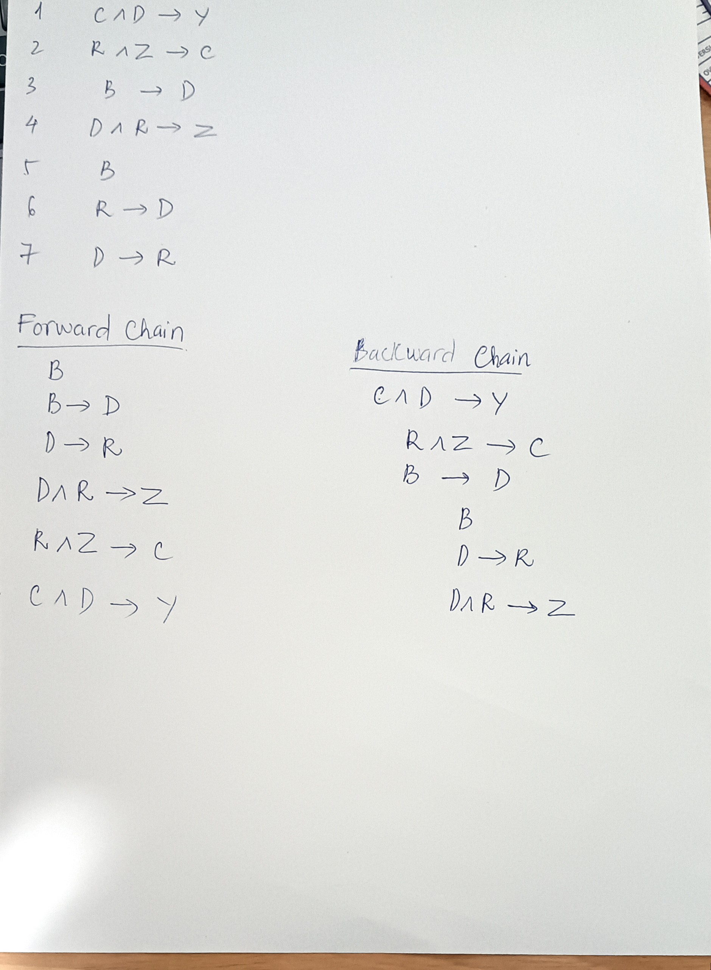

**Question 6.** Consider the following KB.

|  |  |
| --- | --- |
| 1. Buffalo(x)  Pig(y) → Faster(x,y) | 4. Buffalo(Bob) |
| 2. Pig(y)  Slug(z) → Faster (y,z) | 5. Pig(Pat) |
| 3. Faster(x,y)  Faster (y, z) → Faster(x, z) | 6. Slug(Steve) |

Use forward chaining in first-order logic to prove **Faster(Bob, Steve)**. If several rules apply, use the one with the smallest number. Do not forget to indicate the unification at every step.

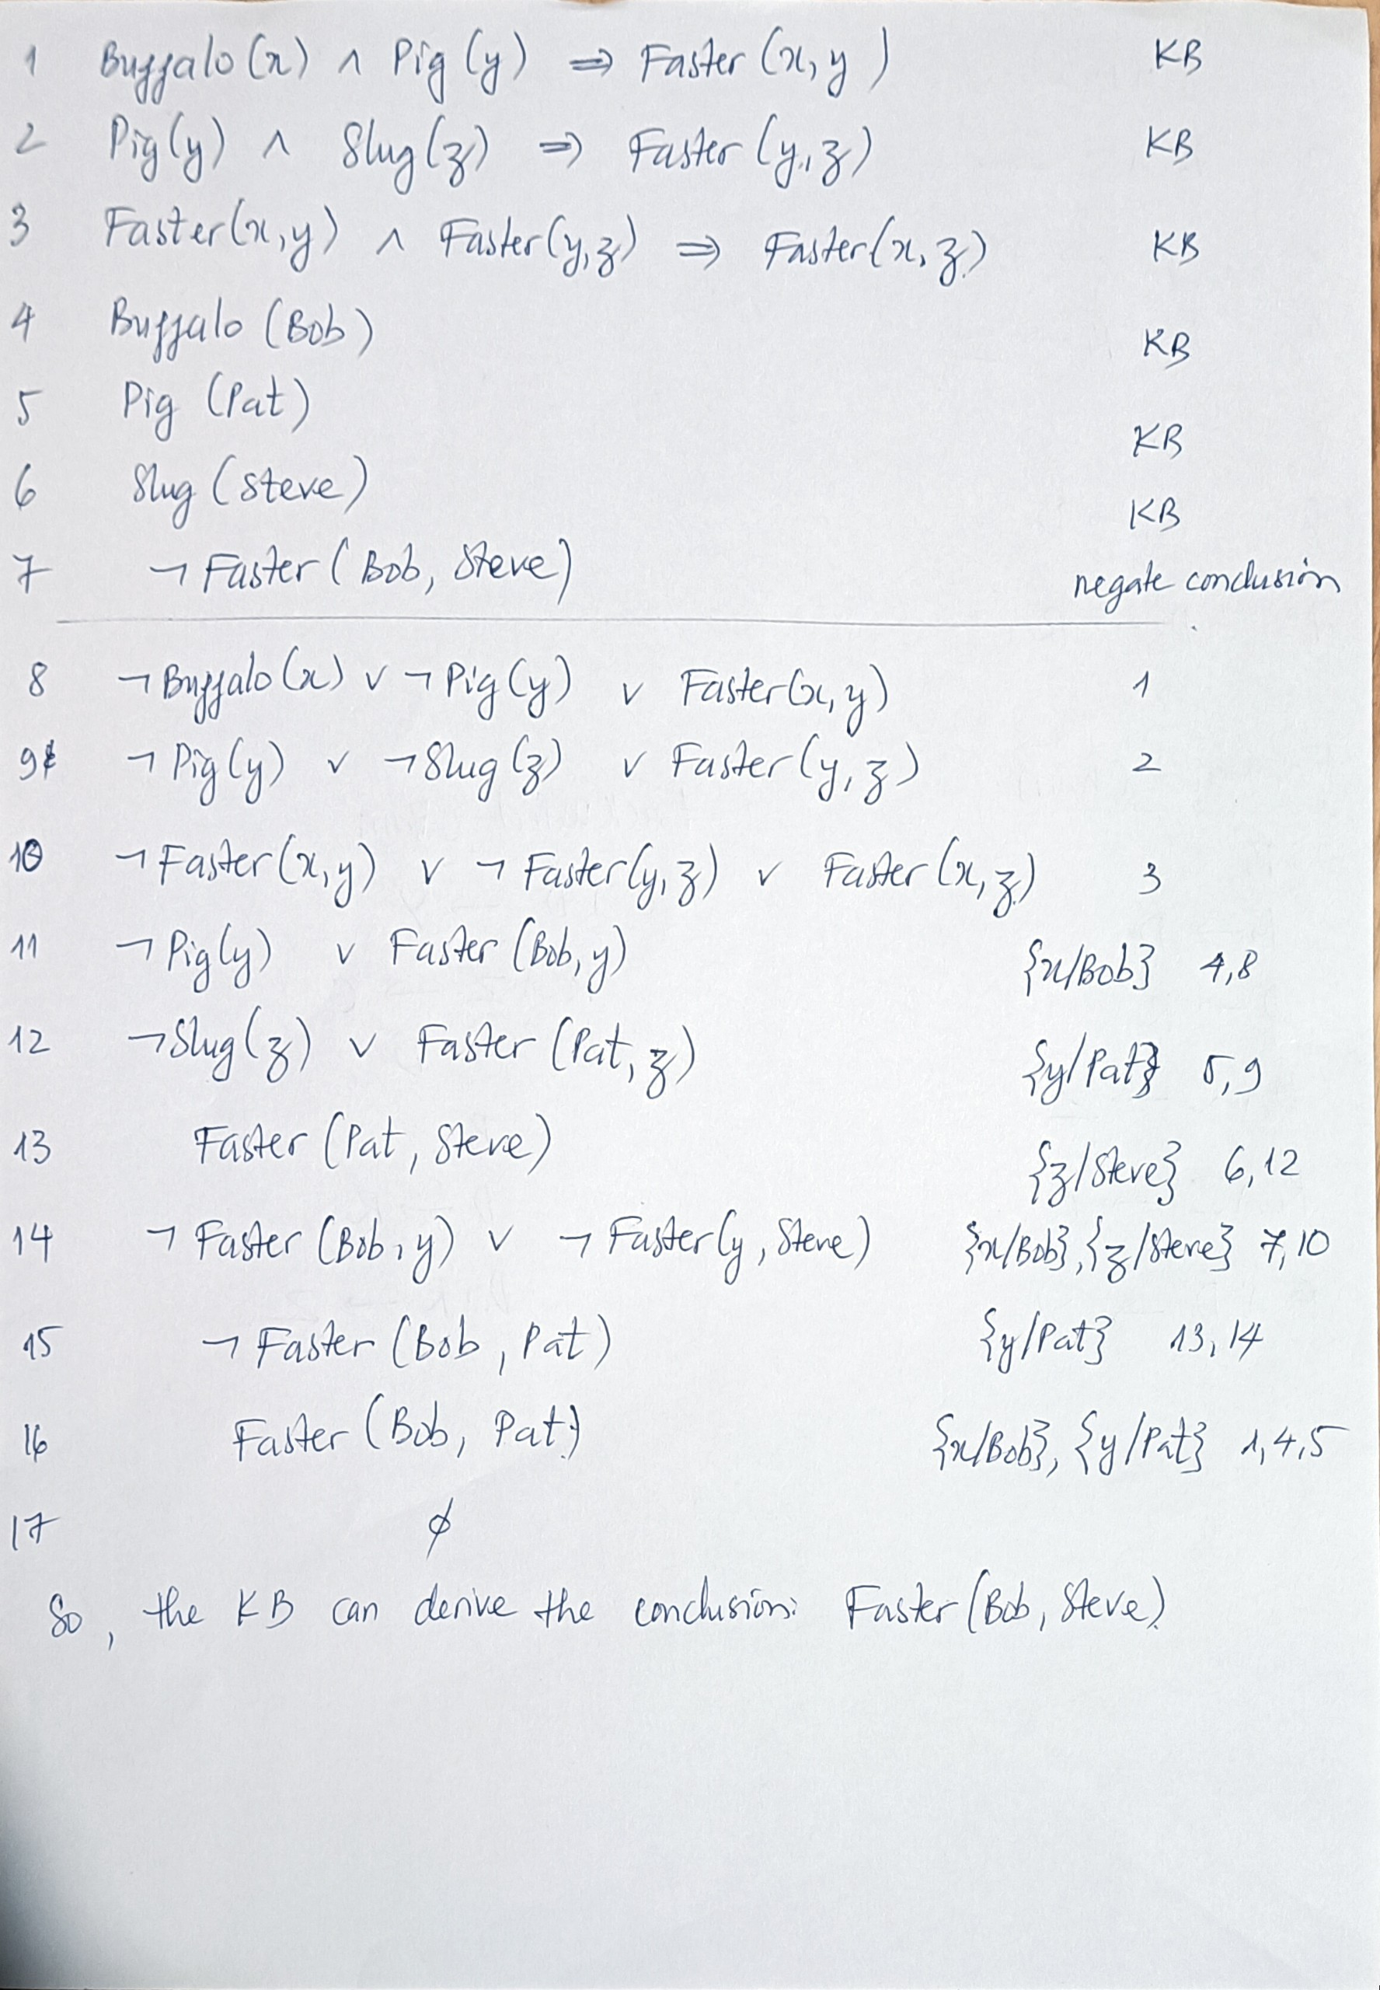

3